Locks Heath Swim Squad
Learning to Use the Pace Clock

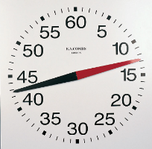

“go” is when you leave the wall.
“go time” is the amount of time you have to swim and rest before starting the next swim.

- If you “go” on the 60, and the “go time” is 30 secs when will you “go” next time? ………………………….

- If you “go” on the 60, and the “go time” is 1 min when will you “go” next time?.................................

- If you “go” on the 60, and the “go” time is 45 secs when will you “go” next time?..............................

- If you “go” on the 15, and the “go” time is 45 secs when will you “go” next time? ……………………………

- If you “go” on the 10, and the “go time” is 40 secs when will you “go” next time?..............................

- If you “go” on the 55, and the “go time” is 35 secs when will you “go” next time?.................................

- If you “go” on the 20, and the “go time” is 45 secs when will you “go” next time?.................................

- If you “go” on the 60, and the “go time” is 1min40secs when will you “go” next time?..........................

- If you “go” on the 15, and the “go time” is 2min30secs when will you “go” next time?..........................

- If you “go” on the 50, and the “go time” is 1min50secs when will you “go” next time?..........................

